# ADD and COPY

COPY and ADD are both Dockerfile instructions that serve similar purposes. They let you copy files from a specific location into a Docker image.

Purpose

Copy the files form source to destination. COPY and ADD both has two forms.

**ADD [--chown=<user>:<group>] <src>... <dest>**

**ADD [--chown=<user>:<group>] ["<src>",... "<dest>"]**

This latter form is required for paths containing whitespace. And COPY

**COPY [--chown=<user>:<group>] <src>... <dest>**

**COPY [--chown=<user>:<group>] ["<src>",... "<dest>"]**

This latter form is required for paths containing whitespace. Create tow sample files.

$ mkdir copy_add

$ cd copy_add

$ echo "this is sample file" > sample.txt

$ echo "this is example file" > example.txt Write a **Dockerfile** using **COPY** and **ADD** FROM busybox

COPY sample.txt /tmp ADD example.txt /tmp CMD ["sh"]

Build the docker image

$ docker build -t copyaddtest . Run as a container

$ docker run -it --name copyaddtest copyaddtest sh Test it

# ls -ltr /tmp

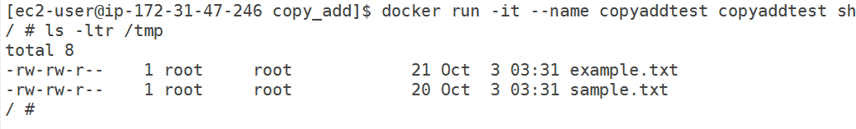

Here as we seen COPY and ADD we can use same purpose but there are couple of difference, lets discuss

# Difference

COPY

* The COPY instruction copies files or directories into the Docker image. * It takes a src and destination as arguments.

* Source can be absolute or relative from current WORKDIR or wild cards. * Destination path can be absolute or relative to current WORKDIR.

For Example:

*COPY ./requirements.txt /app/requirements.txt COPY package.json package-lock.json /app COPY package*.json /app*

*COPY . /app*

ADD

* The ADD instruction copies files, directories, remote file or tar archive into the Docker image.

* It takes a src and destination as arguments. * Source can be files and directories.

* Source can be a URL. The ADD instruction will download the file from the URL and save it to the destination. We don’t need to use curl or wget to download a file.

* Source can be a local tar/zip archive. The ADD instruction will automatically extract it to the destination. We don’t need to run unarchive commands manually.

* Use ADD when you want download a file from a URL or extract local archive file. * For Example:

For Example:

*ADD ./example.tar.gz /tmp/*

*ADD* [https://bootstrap.pypa.io/get-pip.py /get-pip.py](https://bootstrap.pypa.io/get-pip.py/get-pip.py) */get-pip.py ADD example.txt /tmp/*

*ADD* [https://mirrors.estointernet.in/apache/tomcat/tomcat-8/v8.5.58/bin/apache-tomcat-](https://mirrors.estointernet.in/apache/tomcat/tomcat-8/v8.5.58/bin/apache-tomcat-%20%208.5.58.tar.gz) [8.5.58.tar.gz](https://mirrors.estointernet.in/apache/tomcat/tomcat-8/v8.5.58/bin/apache-tomcat-%20%208.5.58.tar.gz) */tmp/*

Create sample tar

$ tar -cvzf example.tar.gz ./

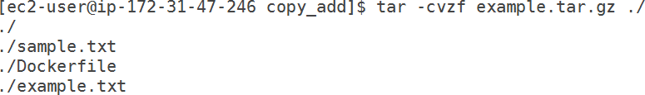

# Use ADD

FROM busybox

ADD example.tar.gz /tmp/ CMD ["sh"]

Build the image

$ docker build -t copyaddtest:v1 . Run the container

$ docker run -it --name copyaddtest1 copyaddtest:v1 sh Test it

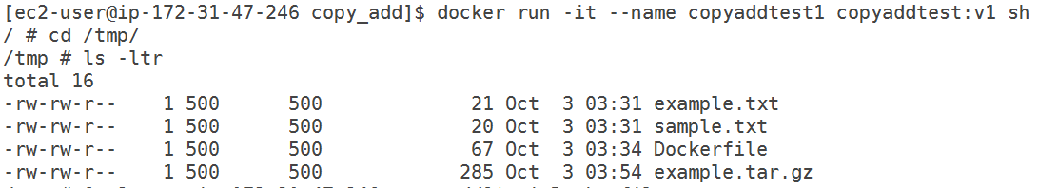

# Use COPY

Write a sample Dockerfile FROM busybox

COPY example.tar.gz /tmp/ CMD ["sh"]

Let’s build the image

$ docker build -t copyaddtest:v2 . Let’s run the container

$ docker run -it --name copyaddtest2 copyaddtest:v2 sh Let’s test it

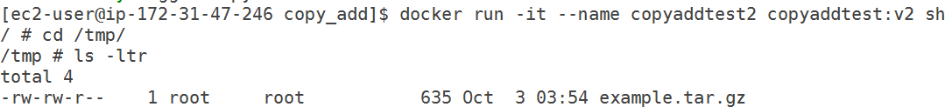

## Conclusion: here ADD command its copied and extracted where COPY only do copy the files. If you want to extract the tar file need to add one more extra command in Dockerfile.

Let’s see… FROM busybox

COPY example.tar.gz /tmp/ WORKDIR /tmp/

RUN tar -xvzf example.tar.gz . CMD ["sh"]

Build the docker image

$ docker build -t copyaddtest:v3 . Run the docker container

$ docker run -it --name copyaddtest3 copyaddtest:v3 sh Let’s test it

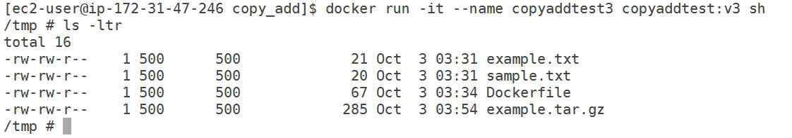

## FROM URL

FROM busybox WORKDIR /tmp/

ADD https://mirrors.estointernet.in/apache/tomcat/tomcat-8/v8.5.58/bin/apache-tomcat- 8.5.58.tar.gz /tmp/

CMD ["sh"]

Build the image

$ docker build -t test:v10 .

Run the container

$ docker run -it --name test10 test:v10 sh Test the container

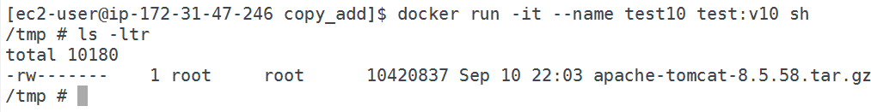

If you want extract tar file you need add RUN tar command. Let’s see FROM busybox

WORKDIR /tmp/

ADD https://mirrors.estointernet.in/apache/tomcat/tomcat-8/v8.5.58/bin/apache-tomcat- 8.5.58.tar.gz /tmp/

RUN tar -xvzf apache-tomcat-8.5.58.tar.gz CMD ["sh"]

Build the image

$ docker build -t test:v11 . Run the container

$ docker run -it --name test11 test:v11 sh Test the container

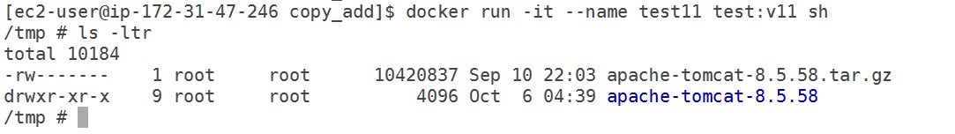

Best practices using ADD and Copy

Instead of using add to download form remote url use curl or wget and use && multiple commands to execute.

FROM ubuntu WORKDIR /tmp/

RUN apt-get update && apt-get install wget -y && wget https://mirrors.estointernet.in/apache/tomcat/tomcat-8/v8.5.58/bin/apache-tomcat-8.5.58.tar.gz && tar xvf apache-tomcat-8.5.58.tar.gz && rm -rf apache-tomcat-8.5.58.tar.gz

CMD ["sh"]

Build the image

$ docker build -t test:v12 .

Run the container

docker run -it --name test12 test:v12 bash test the container



## Finally one more :

One more noteworthy difference between **ADD** and **COPY** is that **COPY** has the **-- from=<name|index>** flag that lets you copy files from a previous build stage in a multi-stage build. **ADD** does not have this option.

This is another reason to use **COPY** as your preferred option.